**DBMS LAB RECORD**

**Name: Nayana J**

**USN:1BM19CS095**

**WEEK 1**

**create database Insurance;**

**use Insurance;**

**CREATE TABLE PERSON(DRIVER_ID VARCHAR(10),NAME VARCHAR(20),ADDRESS VARCHAR(15),PRIMARY KEY(DRIVER_ID));**

**show tables;**

**desc PERSON;**

**SELECT *FROM PERSON;**

**create table car(regno varchar(10),Model varchar(20),Year date,Primary key(Regno));**

**create table Accident(report_no int,ADATE DATE,Location varchar(15),Primary key(report_no));**

**create table owns(driver_id varchar(10),regno varchar(10),primary key(driver_id,regno), foreign key(driver_id) references person(driver_id) on delete cascade, foreign key(regno) references car(regno) on delete cascade);**

**CREATE TABLE PARTICIPATED(driver_id varchar(10),regno varchar(10),report_no int, damage_amt float, foreign key (driver_id,regno) references OWNS(driver_id,regno) ON DELETE CASCADE, foreign key (REPORT_NO) references ACCIDENT(REPORT_NO) ON DELETE CASCADE);**

**show tables;**

**insert into PERSON(DRIVER_ID,NAME,ADDRESS)values('1111','RAMU', 'K.S.LAYOUT');**

**insert into PERSON(DRIVER_ID,NAME,ADDRESS)values('2222','JOHN', 'INDIRANAGAR');**

**insert into PERSON(DRIVER_ID,NAME,ADDRESS)values('3333','PRIYA','JAYANAGAR');**

**insert into PERSON(DRIVER_ID,NAME,ADDRESS)values('4444','GOPAL','WHITEFIELD');**

**insert into PERSON(DRIVER_ID,NAME,ADDRESS)values('5555','LATHA',' VIJAYANAGAR');**

**COMMIT;**

**desc PERSON;**

**SELECT *FROM PERSON;**

**insert into car(regno,Model,Year)values('KA04Q2301','MARUTHI-DX', '2000-10-11');**

**insert into car(regno,Model,Year)values('KA05P1000',' FORDICON','2000-09-08');**

**insert into car(regno,Model,Year)values('KA03L1234','ZEN-VXI', '1999-07-06');**

**insert into car(regno,Model,Year)values('KA03L9999',' MARUTH-DX', '2002-06-05');**

**insert into car(regno,Model,Year)values('KA01P4020',' INDICA-VX', '2002-05-04');**

**COMMIT;**

**desc car;**

**SELECT *FROM car;**

**insert into Accident(report_no,ADATE,Location)values('12',' 2002-06-02',' M G ROAD');**

**insert into Accident(report_no,ADATE,Location)values('200',' 2002-12-10',' DOUBLEROAD');**

**insert into Accident(report_no,ADATE,Location)values('300',' 1999-07-10','M G ROAD');**

**insert into Accident(report_no,ADATE,Location)values('25000',' 2000-06-11',' RESIDENCY ROAD');**

**insert into Accident(report_no,ADATE,Location)values('26500',' 2001-08-12',' RICHMOND ROAD');**

**COMMIT;**

**desc Accident;**

**SELECT *FROM Accident;**

**insert into owns(driver_id,regno)values('1111', 'KA04Q2301');**

**insert into owns(driver_id,regno)values('1111','KA05P1000');**

**insert into owns(driver_id,regno)values('2222','KA03L1234');**

**insert into owns(driver_id,regno)values('3333','KA03L9999');**

**insert into owns(driver_id,regno)values('4444','KA01P4020');**

**COMMIT;**

**desc owns;**

**SELECT *FROM owns;**

**insert into PARTICIPATED(driver_id,regno,report_no,damage_amt)values('1111', 'KA04Q2301',' 12',' 20000');**

**insert into PARTICIPATED(driver_id,regno,report_no,damage_amt)values('2222','KA03L1234','200',' 500');**

**insert into PARTICIPATED(driver_id,regno,report_no,damage_amt)values('3333','KA03L9999','300',' 10000');**

**insert into PARTICIPATED(driver_id,regno,report_no,damage_amt)values('4444','KA01P4020','25000 ','2375');**

**insert into PARTICIPATED(driver_id,regno,report_no,damage_amt)values('1111','KA05P1000','26500','70000');**

**COMMIT;**

**desc PARTICIPATED ;**

**SELECT *FROM PARTICIPATED;**

**/*Update the damage amount for the car with a specific Regno in the accident with report number 12 to 25000.*/**

**UPDATE PARTICIPATED SET DAMAGE_AMT=25000 WHERE REPORT_NO =12 AND REGNO='KA04Q2301';**

**COMMIT;**

**desc PARTICIPATED ;**

**SELECT *FROM PARTICIPATED;**

**/*Add a new accident to the database*/**

**insert into Accident(report_no,ADATE,Location)values('500',' 2005-06-02','Mysore Road');**

**desc Accident;**

**SELECT *FROM Accident;**

**/*Find the total number of people who owned cars that involved in accidents in 2008*/**

**select count(*) from Accident where year(ADATE)=2008;**

**/*Find the number of accidents in which cars belonging to a specific model were involved*/**

**SELECT COUNT(A.REPORT_NO) FROM ACCIDENT A, PARTICIPATED P, CAR C**

**WHERE A.REPORT_NO=P.REPORT_NO AND**

**P.REGNO=C.REGNO AND C.MODEL='MARUTHI-DX';**

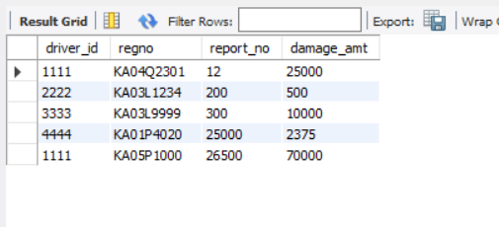

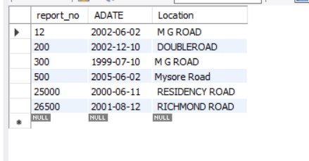

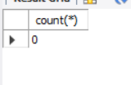

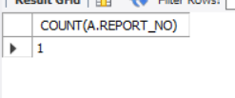

**WEEK 2**

**create database Bookdealer;**

**use Bookdealer;**

**CREATE TABLE AUTHOR(AUTHOR_ID int,NAME varchar(20),CITY VARCHAR(20),COUNTRY VARCHAR(20),PRIMARY KEY(AUTHOR_ID));**

**show tables;**

**desc AUTHOR;**

**SELECT *FROM AUTHOR;**

**create table publisher(publisher_id int, name varchar(20),city varchar(20),country varchar(20),Primary key(publisher_id));**

**create table category(category_id int, description varchar(20),Primary key(category_id));**

**create table catalog(book_id int, title varchar(20),author_id int, publisher_id int, category_id int, year int, price int,Primary key(book_id),**

**foreign key(publisher_id) references publisher(publisher_id) on delete cascade,foreign key(category_id) references category(category_id) on delete cascade);**

**create table order_details(order_no int, book_id int, quantity int,Primary key(order_no),foreign key(book_id) references catalog(book_id) on delete cascade);**

**show tables;**

**insert into AUTHOR(AUTHOR_ID,NAME,CITY,COUNTRY)values('1001','TERAS CHAN','CA','USA');**

**insert into AUTHOR(AUTHOR_ID,NAME,CITY,COUNTRY)values('1002','STEVENS','ZOMBI','UGANDA');**

**insert into AUTHOR(AUTHOR_ID,NAME,CITY,COUNTRY)values('1003','M MANO','CAIR','UGANDA');**

**insert into AUTHOR(AUTHOR_ID,NAME,CITY,COUNTRY)values('1004','KARHTIK B P','NY','USA');**

**insert into AUTHOR(AUTHOR_ID,NAME,CITY,COUNTRY)values('1005','WILLIAM STALLINGS','LAS VEGAS','USA');**

**COMMIT;**

**desc AUTHOR;**

**SELECT *FROM AUTHOR;**

**insert into PUBLISHER(publisher_id,NAME,CITY,COUNTRY)values('1','PEARSON','NEW YORK',' USA');**

**insert into PUBLISHER(publisher_id,NAME,CITY,COUNTRY)values('2','EEE','NEW SOUTH VALES',' USA');**

**insert into PUBLISHER(publisher_id,NAME,CITY,COUNTRY)values('3','PHI','DELHI',' INDIA');**

**insert into PUBLISHER(publisher_id,NAME,CITY,COUNTRY)values('4','WILLEY','BERLIN','GERMANY');**

**insert into PUBLISHER(publisher_id,NAME,CITY,COUNTRY)values('5','MGH','NEW YORK',' USA');**

**COMMIT;**

**desc PUBLISHER;**

**SELECT * FROM PUBLISHER;**

**insert into CATEGORY(CATEGORY_ID, DESCRIPTION)values('1001','COMPUTER SCIENCE');**

**insert into CATEGORY(CATEGORY_ID, DESCRIPTION)values('1002','ALGORITHM DESIGN');**

**insert into CATEGORY(CATEGORY_ID, DESCRIPTION)values('1003','ELECTRONICS');**

**insert into CATEGORY(CATEGORY_ID, DESCRIPTION)values('1004','PROGRAMMING');**

**insert into CATEGORY(CATEGORY_ID, DESCRIPTION)values('1005','OPERATING SYSTEMS');**

**COMMIT;**

**desc CATEGORY;**

**SELECT * FROM CATEGORY;**

**insert into CATALOG(BOOK_ID,TITLE,AUTHOR_ID,PUBLISHER_ID,CATEGORY_ID,YEAR,PRICE)values('11',' Unix System Prg','1001','1','1001','2000','251');**

**insert into CATALOG(BOOK_ID,TITLE,AUTHOR_ID,PUBLISHER_ID,CATEGORY_ID,YEAR,PRICE)values('12',' Digital Signals',' 1002',' 2','1003',' 2001','425');**

**insert into CATALOG(BOOK_ID,TITLE,AUTHOR_ID,PUBLISHER_ID,CATEGORY_ID,YEAR,PRICE)values('13',' Logic Design',' 1003',' 3','1002',' 1999','225');**

**insert into CATALOG(BOOK_ID,TITLE,AUTHOR_ID,PUBLISHER_ID,CATEGORY_ID,YEAR,PRICE)values('14','Server Prg','1004','4','1004','2001','333');**

**insert into CATALOG(BOOK_ID,TITLE,AUTHOR_ID,PUBLISHER_ID,CATEGORY_ID,YEAR,PRICE)values('15','Linux OS',' 1005',' 5','1005',' 2003','326');**

**insert into CATALOG(BOOK_ID,TITLE,AUTHOR_ID,PUBLISHER_ID,CATEGORY_ID,YEAR,PRICE)values('16',' C++ Bible',' 1005',' 5',' 1001','2000','526');**

**insert into CATALOG(BOOK_ID,TITLE,AUTHOR_ID,PUBLISHER_ID,CATEGORY_ID,YEAR,PRICE)values('17',' COBOL Handbook',' 1005',' 4',' 1001','2000','658');**

**COMMIT;**

**desc CATALOG;**

**SELECT * FROM CATALOG;**

**insert into ORDER_DETAILS(ORDER_NO,BOOK_ID,QUANTITY)values('1',' 11',' 5');**

**insert into ORDER_DETAILS(ORDER_NO,BOOK_ID,QUANTITY)values('2','12','8');**

**insert into ORDER_DETAILS(ORDER_NO,BOOK_ID,QUANTITY)values('3','13','15');**

**insert into ORDER_DETAILS(ORDER_NO,BOOK_ID,QUANTITY)values('4','14','22');**

**insert into ORDER_DETAILS(ORDER_NO,BOOK_ID,QUANTITY)values('5','15','3');**

**insert into ORDER_DETAILS(ORDER_NO,BOOK_ID,QUANTITY)values('2','17','10');**

**COMMIT;**

**show tables;**

**desc ORDER_DETAILS;**

**SELECT *FROM ORDER_DETAILS;**

**iii) Give the details of the authors who have 2 or more books in the catalog and the price of the books in the catalog and the year of publication is after 2000.**

**SELECT AUTHOR.author_id,name,city,country FROM AUTHOR,CATALOG where AUTHOR.author_id=CATALOG.author_id group by CATALOG.author_id having count(CATALOG.author_id)>=2;**

**SELECT PRICE FROM CATALOG where year>2000;**

**iv) Find the author of the book which has maximum sales.**

**select name from AUTHOR,CATALOG where AUTHOR.author_id=CATALOG.author_id and book_id in(select book_id from ORDER_DETAILS where quantity=(select max(quantity) from ORDER_DETAILS));**

**v) Demonstrate how you increase the price of books published by a specific publisher by 10%.**

**update CATALOG set price=1.1*price where publisher_id in(select publisher_id from PUBLISHER where name='PEARSON');**

**SELECT *FROM CATALOG;**

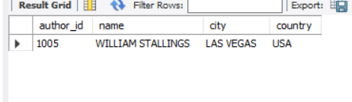

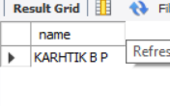

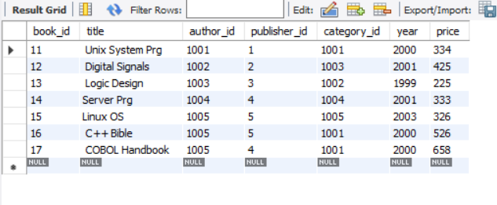

**WEEK 3**

**CREATE DATABASE ORDER_PROCESSING;**

**USE ORDER_PROCESSING;**

**CREATE TABLE CUSTOMER(CUST_ID INT,CNAME VARCHAR(30),CITY VARCHAR(30),PRIMARY KEY(CUST_ID));**

**CREATE TABLE ORDERS(ORDER_ID INT,ORDER_DATE DATE,CUST_ID INT,ORDER_AMOUNT INT,PRIMARY KEY(ORDER_ID),**

**FOREIGN KEY(CUST_ID) REFERENCES CUSTOMER(CUST_ID) ON DELETE CASCADE);**

**CREATE TABLE ITEM(ITEM_ID INT,UNITPRICE INT,PRIMARY KEY(ITEM_ID));**

**CREATE TABLE ORDERITEM(ORDER_ID INT,ITEM_ID INT,QTY INT,**

**FOREIGN KEY(ORDER_ID) REFERENCES ORDERS(ORDER_ID) ON DELETE SET NULL,FOREIGN KEY(ITEM_ID) REFERENCES ITEM(ITEM_ID) ON DELETE SET NULL);**

**CREATE TABLE WAREHOUSE(WAREHOUSE_ID INT,CITY VARCHAR(30),PRIMARY KEY(WAREHOUSE_ID));**

**CREATE TABLE SHIPMENT(ORDER_ID INT,WAREHOUSE_ID INT,SHIPDATE DATE,**

**FOREIGN KEY(ORDER_ID) REFERENCES ORDERS(ORDER_ID) ON DELETE CASCADE,**

**FOREIGN KEY(WAREHOUSE_ID) REFERENCES WAREHOUSE(WAREHOUSE_ID) ON DELETE CASCADE);**

**SHOW TABLES;**

**INSERT INTO CUSTOMER(CUST_ID,CNAME,CITY) VALUES (771, 'PUSHPA K','BANGALORE');**

**INSERT INTO CUSTOMER(CUST_ID,CNAME,CITY) VALUES(772, 'SUMAN', 'MUMBAI');**

**INSERT INTO CUSTOMER(CUST_ID,CNAME,CITY) VALUES(773,'SOURAV','CALICUT');**

**INSERT INTO CUSTOMER(CUST_ID,CNAME,CITY) VALUES(774, 'LAILA', 'HYDERABAD');**

**INSERT INTO CUSTOMER(CUST_ID,CNAME,CITY) VALUES(775, 'FAIZAL',' BANGALORE');**

**DESC CUSTOMER;**

**SELECT * FROM CUSTOMER;**

**INSERT INTO ORDERS(ORDER_ID,ORDER_DATE,CUST_ID,ORDER_AMOUNT) VALUES (111, '2002-01-22', 771, 18000);**

**INSERT INTO ORDERS(ORDER_ID,ORDER_DATE,CUST_ID,ORDER_AMOUNT) VALUES(112, '2002-07-30', 774, 6000);**

**INSERT INTO ORDERS(ORDER_ID,ORDER_DATE,CUST_ID,ORDER_AMOUNT) VALUES(113, '2003-04-03', 775, 9000);**

**INSERT INTO ORDERS(ORDER_ID,ORDER_DATE,CUST_ID,ORDER_AMOUNT) VALUES(114, '2003-11-03', 775, 29000);**

**INSERT INTO ORDERS(ORDER_ID,ORDER_DATE,CUST_ID,ORDER_AMOUNT) VALUES(115, '2003-12-10', 773, 29000);**

**INSERT INTO ORDERS(ORDER_ID,ORDER_DATE,CUST_ID,ORDER_AMOUNT) VALUES(116, '2004-08-19', 772, 56000);**

**INSERT INTO ORDERS(ORDER_ID,ORDER_DATE,CUST_ID,ORDER_AMOUNT) VALUES(117, '2004-09-10', 771, 20000);**

**INSERT INTO ORDERS(ORDER_ID,ORDER_DATE,CUST_ID,ORDER_AMOUNT) VALUES(118, '2004-11-20',775, 29000);**

**INSERT INTO ORDERS(ORDER_ID,ORDER_DATE,CUST_ID,ORDER_AMOUNT) VALUES(119, '2005-02-13', 774, 29000);**

**INSERT INTO ORDERS(ORDER_ID,ORDER_DATE,CUST_ID,ORDER_AMOUNT) VALUES(120, '2005-10-13', 775 ,29000);**

**DESC ORDERS;**

**SELECT * FROM ORDERS;**

**INSERT INTO ITEM(ITEM_ID, UNITPRICE) VALUES (5001, 503);**

**INSERT INTO ITEM(ITEM_ID, UNITPRICE) VALUES(5002, 750);**

**INSERT INTO ITEM(ITEM_ID, UNITPRICE) VALUES(5003, 150);**

**INSERT INTO ITEM(ITEM_ID, UNITPRICE) VALUES(5004, 600);**

**INSERT INTO ITEM(ITEM_ID, UNITPRICE) VALUES(5005, 890);**

**DESC ITEM;**

**SELECT * FROM ITEM;**

**INSERT INTO ORDERITEM(ORDER_ID,ITEM_ID,QTY) VALUES(111, 5001, 50);**

**INSERT INTO ORDERITEM(ORDER_ID,ITEM_ID,QTY) VALUES(112, 5003, 20);**

**INSERT INTO ORDERITEM(ORDER_ID,ITEM_ID,QTY) VALUES(113, 5002, 50);**

**INSERT INTO ORDERITEM(ORDER_ID,ITEM_ID,QTY) VALUES(114, 5005, 60);**

**INSERT INTO ORDERITEM(ORDER_ID,ITEM_ID,QTY) VALUES(115, 5004, 90);**

**INSERT INTO ORDERITEM(ORDER_ID,ITEM_ID,QTY) VALUES(116, 5001, 10);**

**INSERT INTO ORDERITEM(ORDER_ID,ITEM_ID,QTY) VALUES(117, 5003, 80);**

**INSERT INTO ORDERITEM(ORDER_ID,ITEM_ID,QTY) VALUES(118, 5005, 50);**

**INSERT INTO ORDERITEM(ORDER_ID,ITEM_ID,QTY) VALUES(119, 5002, 10);**

**INSERT INTO ORDERITEM(ORDER_ID,ITEM_ID,QTY) VALUES(120, 5004, 45);**

**DESC ORDERITEM;**

**SELECT * FROM ORDERITEM;**

**INSERT INTO WAREHOUSE(WAREHOUSE_ID,CITY) VALUES (1,'DELHI');**

**INSERT INTO WAREHOUSE(WAREHOUSE_ID,CITY) VALUES(2,'BOMBAY');**

**INSERT INTO WAREHOUSE(WAREHOUSE_ID,CITY) VALUES(3,'CHENNAI');**

**INSERT INTO WAREHOUSE(WAREHOUSE_ID,CITY) VALUES(4,'BANGALORE');**

**INSERT INTO WAREHOUSE(WAREHOUSE_ID,CITY) VALUES(5,'BANGALORE');**

**INSERT INTO WAREHOUSE(WAREHOUSE_ID,CITY) VALUES(6,'DELHI');**

**INSERT INTO WAREHOUSE(WAREHOUSE_ID,CITY) VALUES(7,'BOMBAY');**

**INSERT INTO WAREHOUSE(WAREHOUSE_ID,CITY) VALUES(8,'CHENNAI');**

**INSERT INTO WAREHOUSE(WAREHOUSE_ID,CITY) VALUES(9,'DELHI');**

**INSERT INTO WAREHOUSE(WAREHOUSE_ID,CITY) VALUES(10,'BANGALORE');**

**DESC WAREHOUSE;**

**SELECT * FROM WAREHOUSE;**

**INSERT INTO SHIPMENT(ORDER_ID,WAREHOUSE_ID,SHIPDATE) VALUES (111,1,'2002-02-10');**

**INSERT INTO SHIPMENT(ORDER_ID,WAREHOUSE_ID,SHIPDATE) VALUES(112, 5 ,'2002-09-10');**

**INSERT INTO SHIPMENT(ORDER_ID,WAREHOUSE_ID,SHIPDATE) VALUES(113, 8 ,'2003-02-10');**

**INSERT INTO SHIPMENT(ORDER_ID,WAREHOUSE_ID,SHIPDATE) VALUES(114, 3 ,'2003-12-10');**

**INSERT INTO SHIPMENT(ORDER_ID,WAREHOUSE_ID,SHIPDATE) VALUES(115,9 ,'2004-01-19');**

**INSERT INTO SHIPMENT(ORDER_ID,WAREHOUSE_ID,SHIPDATE) VALUES(116, 1, '2004-09-20');**

**INSERT INTO SHIPMENT(ORDER_ID,WAREHOUSE_ID,SHIPDATE) VALUES(117, 5 ,'2004-09-10');**

**INSERT INTO SHIPMENT(ORDER_ID,WAREHOUSE_ID,SHIPDATE) VALUES(118, 7 ,'2004-11-30');**

**INSERT INTO SHIPMENT(ORDER_ID,WAREHOUSE_ID,SHIPDATE) VALUES(119, 7 ,'2005-04-30');**

**INSERT INTO SHIPMENT(ORDER_ID,WAREHOUSE_ID,SHIPDATE) VALUES(120, 6 ,'2005-12-21');**

**DESC SHIPMENT;**

**SELECT * FROM SHIPMENT;**

**/* iii */**

**SELECT C.CNAME,COUNT(O.ORDER_ID) AS TOTALORDERS,AVG(O.ORDER_AMOUNT) AS AVG_ORDER_AMT FROM CUSTOMER C,ORDERS O WHERE C.CUST_ID=O.CUST_ID GROUP BY O.CUST_ID;**

**/* iv */**

**SELECT S.ORDER_ID FROM SHIPMENT S,WAREHOUSE W WHERE S.WAREHOUSE_ID=W.WAREHOUSE_ID AND W.CITY="BANGALORE";**

**/* v */**

**DELETE FROM ITEM WHERE ITEM_ID=5002;**

**SELECT * FROM ORDERITEM;**

**COMMIT;**

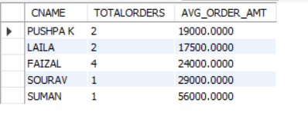

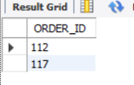

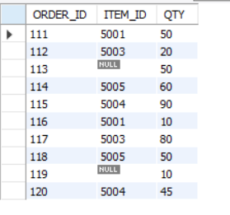

**WEEK 4**

**CREATE DATABASE BANKING;**

**USE BANKING;**

**create table branch(branch_name varchar(30) primary key,branch_city varchar(30),assets real);**

**create table accounts(accno int primary key,branch_name varchar(30),balance real,**

**foreign key (branch_name) references branch(branch_name) on delete cascade on update cascade);**

**create table customer(customer_name varchar(30) primary key,customer_street varchar(20),customer_city varchar(20));**

**create table depositor(customer_name varchar(30),accno int,primary key(customer_name ,accno),**

**foreign key (accno) references accounts(accno) on delete cascade on update cascade,**

**foreign key (customer_name) references customer(customer_name) on delete cascade on update cascade);**

**create table loan(loan_number int primary key,branch_name varchar(30),amount real,foreign key (branch_name) references branch(branch_name));**

**create table borrower (customer_name varchar(30),loan_number int,primary key(customer_name, loan_number),**

**foreign key (customer_name) references customer(customer_name) on delete cascade on update cascade,**

**foreign key (loan_number) references loan(loan_number) on delete cascade on update cascade);**

**show tables;**

**insert into branch(branch_name,branch_city,assets) values ('A','Bangalore',190000),**

**('B','Bangalore',200000),**

**('C','Delhi',235344),**

**('D','Chennai',1050560),**

**('E','Chennai',678909);**

**select * from branch;**

**insert into accounts(accno,branch_name,balance) VALUES (1001,'A',10000),**

**(1002,'B',5000),**

**(1003,'C',7500),**

**(1004,'D',50000),**

**(1005,'D',75000),**

**(1006,'E',560),**

**(1007,"B",500),**

**(1008,"B",1500);**

**select * from accounts;**

**insert into customer(customer_name,customer_street,customer_city) VALUES ("Ravi","Dasarahalli","Bangalore"),**

**("Shyam","Indiranagar","Delhi"),**

**("Seema","Vasantnagar","Chennai"),**

**("Arpita","Church Street","Bangalore"),**

**("Vinay","MG Road","Chennai");**

**select * from customer;**

**insert into depositor(customer_name,accno) VALUES ("Ravi",1001),**

**("Ravi",1002),**

**("Shyam",1003),**

**("Seema",1004),**

**("Seema",1005),**

**("Arpita",1006),**

**("Vinay",1007),**

**("Vinay",1008);**

**select * from depositor;**

**insert into loan(loan_number,branch_name,amount) VALUES (001,'A',10000),**

**(002,'B',25000),**

**(003,'B',250000),**

**(004,'C',5000),**

**(005,'E',90000);**

**select * from loan;**

**insert into borrower(customer_name,loan_number) VALUES ("Arpita",001),**

**("Ravi",002),**

**("Arpita",003),**

**("Shyam",004),**

**("Vinay",005);**

**select * from borrower;**

**/* iii*/**

**select d.customer_name from depositor d,accounts a where d.accno=a.accno and a.branch_name = "D"**

**group by d.customer_name having count(d.customer_name) >=2;**

**/* iv*/**

**select customer_name from depositor join accounts on accounts.accno = depositor.accno join branch on branch.branch_name = accounts.branch_name**

**where branch.branch_city = "Bangalore" GROUP BY depositor.customer_name**

**having count(DISTINCT branch.branch_name) = (SELECT COUNT(branch_name) FROM branch WHERE branch_city = 'Bangalore');**

**/* v*/**

**delete from accounts where branch_name in(select branch_name from branch where branch_city="Delhi");**

**select * from accounts;**

**COMMIT;**

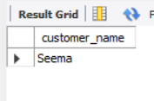

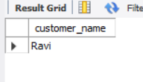

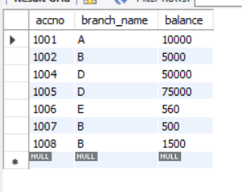

**WEEK 5**

**create database Student_Enrollment;**

**use Student_enrollment;**

**create table student(regno varchar(10) primary key,name varchar(10),major varchar(10),bdate date);**

**create table course(course_no int primary key,cname varchar(10),dept varchar(10));**

**create table enroll(regno varchar(10),course_no int,sem int, marks int,**

**foreign key(regno) references student(regno) on delete cascade set null,**

**foreign key(course_no) references course(course_no) on delete cascade);**

**create table text_book(book_isbn int primary key,book_title varchar(20),publisher varchar(10),author varchar(10));**

**create table book_adoption(course_no int,sem int,book_isbn int ,**

**foreign key(course_no) references course(course_no) on delete cascade,**

**foreign key(book_isbn) references text_book(book_isbn) on delete cascade);**

**insert into student(regno,name,major,bdate) values**

**("cs01","ram","ds",'1986-03-12'),**

**("is02","smith","usp",'1987-12-23'),**

**("ec03","ahmed","sns",'1985-04-17'),**

**("cs03","sneha","dbms",'1987-01-01'),**

**("tc05","akhila","ec",'1986-10-06');**

**select * from student;**

**insert into course(course_no,cname,dept) values**

**(11,"ds","cs"),**

**(22,"usp","is"),**

**(33,"sns","ec"),**

**(44,"dbms","cs"),**

**(55,"ec","tc");**

**select * from course;**

**insert into enroll(regno,course_no,sem,marks) values**

**("cs01",11,4,85),**

**("is02",22,6,80),**

**("ec03",33,2,80),**

**("cs03",44,6,75),**

**("tc05",55,2,80);**

**select * from enroll;**

**insert into text_book(book_isbn,book_title,publisher,author) values**

**(1,"ds and c","princeton","padma"),**

**(2,"fundamentals of ds","princeton","godse"),**

**(3,"fundamentals of dbms","princeton","navathe"),**

**(4,"sql","princeton","foley"),**

**(5,"electronic circuits","tmh","elmarsi"),**

**(6,"adv unix program","tmh","stevens");**

**select * from text_book;**

**insert into book_adoption(course_no,sem,book_isbn) values**

**(11,4,1),(11,4,2),(44,6,3),(44,6,4),(55,2,5),(22,6,6);**

**select * from book_adoption;**

**/*add a new text book to the database and make this book be adopted by some department*/**

**insert into text_book values(7,"database basics","princeton","shawn");**

**insert into book_adoption values(11,4,7);**

**select * from text_book;**

**select * from book_adoption;**

**/*a list of text books in the alphabetical order for courses offered by the ‘CS’ department that use more than two books.*/**

**select c.course_no,t.book_isbn,t.book_title from course c, text_book t,book_adoption b**

**where t.book_isbn=b.book_isbn and b.course_no=c.course_no and c.dept="cs" and**

**(select count(b.book_isbn) from book_adoption b where c.course_no=b.course_no)>2 order by t.book_title;**

**/*List any department that has all its adopted books published by a specific publisher*/**

**select distinct c.dept from course c where c.dept in (select c.dept**

**from course c,book_adoption b,text_book t where c.course_no=b.course_no**

**and t.book_isbn=b.book_isbn and t.publisher="tmh")**

**and c.dept not in (select c.dept**

**from course c,book_adoption b,text_book t where c.course_no=b.course_no**

**and t.book_isbn=b.book_isbn and t.publisher!="tmh") ;**

**commit;**

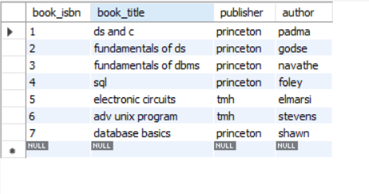

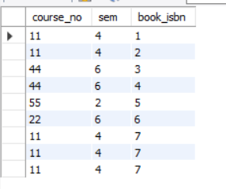

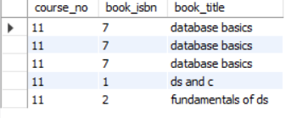

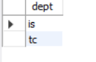

**THE END**